LAB 6

Write Python code to implement the following. Consider dataset files as “iris.csv” and “diabetes.csv”
1. Build a KNN classifier to classify IRIS flower dataset. Choose appropriate k value and predict the score, display confusion matrix and classification report. Use 80% of data for training and 20% for testing. Display accuracy score and confusion matrix of the trained model on test data
import pandas as pd
df1=pd.read_csv("iris.csv")
from sklearn.model_selection import train_test_split
from sklearn.neighbors import KNeighborsClassifier
from sklearn.metrics import accuracy_score, confusion_matrix, classification_report
import matplotlib.pyplot as plt
import seaborn as sns
import numpy as np

X_iris = df1.drop('species', axis=1)
y_iris = df1['species']

# Split data into training and testing sets (80% train, 20% test)
X_train_iris, X_test_iris, y_train_iris, y_test_iris = train_test_split(
X_iris, y_iris, test_size=0.2, random_state=42, stratify=y_iris
)

print("Iris Dataset Split:")
print(f"Training features shape: {X_train_iris.shape}")
print(f"Testing features shape: {X_test_iris.shape}")
print(f"Training target shape: {y_train_iris.shape}")
print(f"Testing target shape: {y_test_iris.shape}")

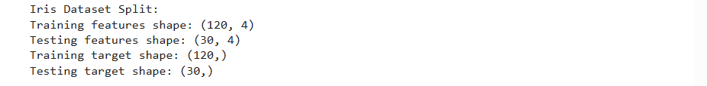

error_rate_iris = []

for i in range(1, 21):
knn = KNeighborsClassifier(n_neighbors=i)
knn.fit(X_train_iris, y_train_iris)
pred_i = knn.predict(X_test_iris)
error_rate_iris.append(np.mean(pred_i != y_test_iris))

plt.figure(figsize=(10, 6))
plt.plot(range(1, 21), error_rate_iris, color='blue', linestyle='dashed', marker='o',
markerfacecolor='red', markersize=10)
plt.title('Error Rate vs. K Value for Iris')
plt.xlabel('K Value')
plt.ylabel('Error Rate')
plt.xticks(np.arange(1, 21, 1))
plt.grid(True)
plt.show()
k_iris = 5
print(f"Chosen K value for Iris: {k_iris}")

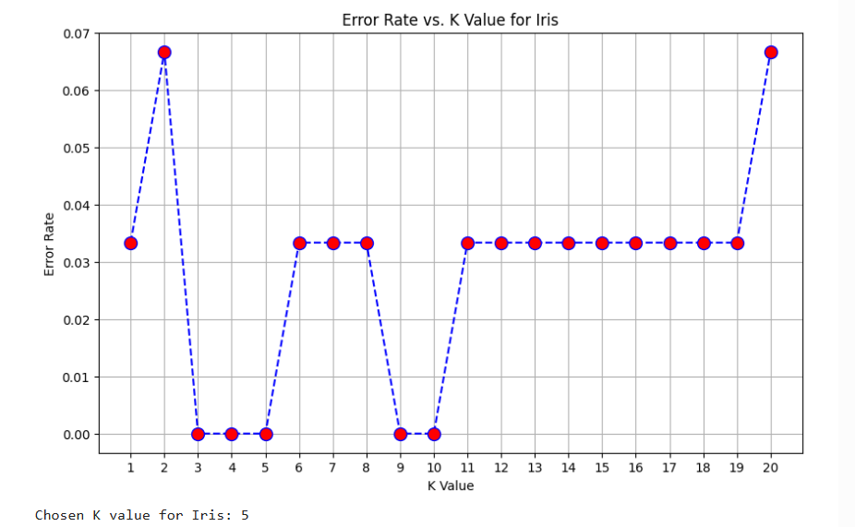
knn_iris = KNeighborsClassifier(n_neighbors=k_iris)

knn_iris.fit(X_train_iris, y_train_iris)

y_pred_iris = knn_iris.predict(X_test_iris)

accuracy_iris = accuracy_score(y_test_iris, y_pred_iris)
print(f"Accuracy Score for Iris KNN: {accuracy_iris:.4f}")

conf_matrix_iris = confusion_matrix(y_test_iris, y_pred_iris)
print("\nConfusion Matrix for Iris:\n")
display(conf_matrix_iris)

class_report_iris = classification_report(y_test_iris, y_pred_iris)
print("\nClassification Report for Iris:\n")
print(class_report_iris)

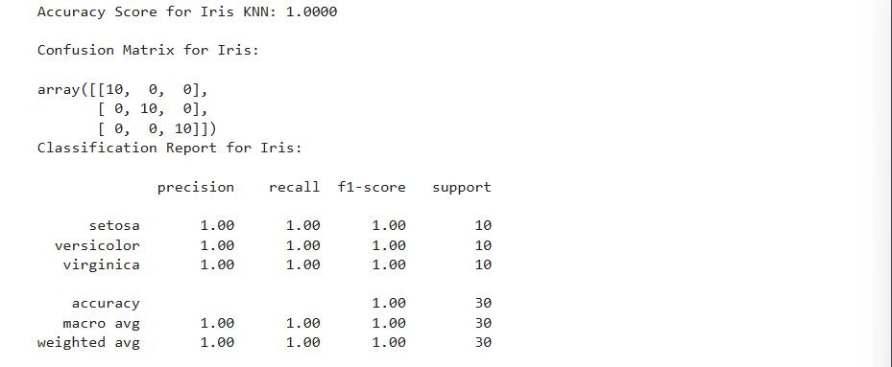

2. Build a KNN classifier to classify diabetes dataset. Choose k value and perform feature scaling. Use 80% of data for training and 20% for testing. Display accuracy score and confusion matrix of the trained model on test data.
df2=pd.read_csv("diabetes.csv")
from sklearn.preprocessing import StandardScaler

X_diabetes = df2.drop('Outcome', axis=1)
y_diabetes = df2['Outcome']

# Split data into training and testing sets (80% train, 20% test)
X_train_diabetes, X_test_diabetes, y_train_diabetes, y_test_diabetes = train_test_split(
X_diabetes, y_diabetes, test_size=0.2, random_state=42, stratify=y_diabetes
)

print("Diabetes Dataset Split:")
print(f"Training features shape: {X_train_diabetes.shape}")
print(f"Testing features shape: {X_test_diabetes.shape}")
print(f"Training target shape: {y_train_diabetes.shape}")
print(f"Testing target shape: {y_test_diabetes.shape}")
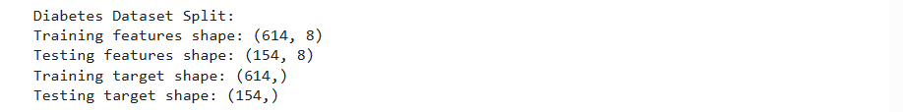

scaler = StandardScaler()
X_train_scaled_diabetes = scaler.fit_transform(X_train_diabetes)
X_test_scaled_diabetes = scaler.transform(X_test_diabetes)

print("Features scaled for Diabetes dataset.")
print("First 5 rows of scaled training data:")
display(pd.DataFrame(X_train_scaled_diabetes, columns=X_diabetes.columns).head())
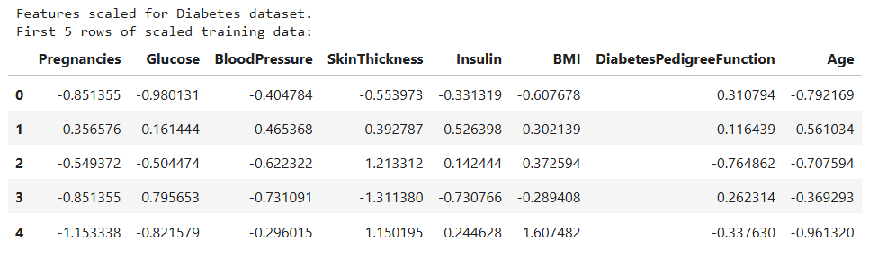
error_rate_diabetes = []

for i in range(1, 21):
knn = KNeighborsClassifier(n_neighbors=i)
knn.fit(X_train_scaled_diabetes, y_train_diabetes)
pred_i = knn.predict(X_test_scaled_diabetes)
error_rate_diabetes.append(np.mean(pred_i != y_test_diabetes))

plt.figure(figsize=(10, 6))
plt.plot(range(1, 21), error_rate_diabetes, color='blue', linestyle='dashed', marker='o',
markerfacecolor='red', markersize=10)
plt.title('Error Rate vs. K Value for Diabetes')
plt.xlabel('K Value')
plt.ylabel('Error Rate')
plt.xticks(np.arange(1, 21, 1))
plt.grid(True)
plt.show()

k_diabetes = 11
print(f"Chosen K value for Diabetes: {k_diabetes}")
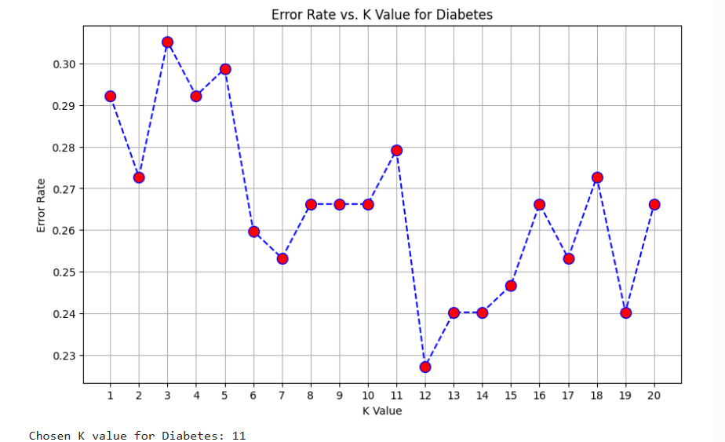
knn_diabetes = KNeighborsClassifier(n_neighbors=k_diabetes)
knn_diabetes.fit(X_train_scaled_diabetes, y_train_diabetes)
y_pred_diabetes = knn_diabetes.predict(X_test_scaled_diabetes)
accuracy_diabetes = accuracy_score(y_test_diabetes, y_pred_diabetes)
print(f"Accuracy Score for Diabetes KNN: {accuracy_diabetes:.4f}")

conf_matrix_diabetes = confusion_matrix(y_test_diabetes, y_pred_diabetes)
print("\nConfusion Matrix for Diabetes:\n")
display(conf_matrix_diabetes)

class_report_diabetes = classification_report(y_test_diabetes, y_pred_diabetes)
print("\nClassification Report for Diabetes:\n")
print(class_report_diabetes)

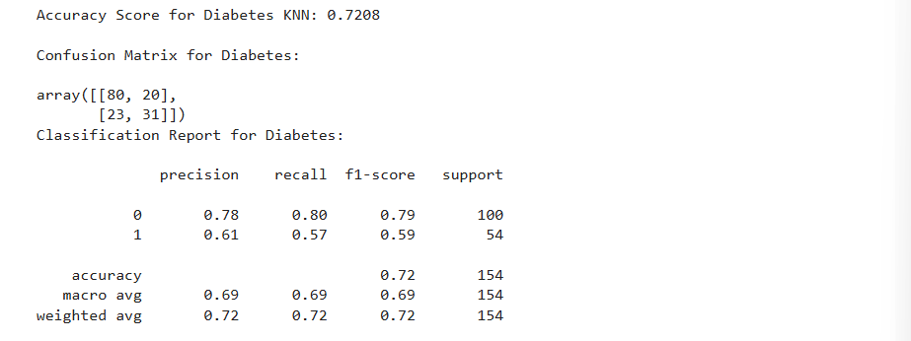

3. Using heart.csv dataset and do following
a. Classify the target using KNN classifier. You can use different values for k neighbors and need to figure out a value of K that gives you a maximum score.
b. Plot confusion matrix
c. Plot classification report
df3=pd.read_csv("heart.csv")
from sklearn.model_selection import train_test_split
from sklearn.neighbors import KNeighborsClassifier
from sklearn.metrics import accuracy_score, confusion_matrix, classification_report
from sklearn.preprocessing import StandardScaler
import matplotlib.pyplot as plt
import seaborn as sns
import numpy as np

X_heart = df3.drop('target', axis=1)
y_heart = df3['target']
X_train_heart, X_test_heart, y_train_heart, y_test_heart = train_test_split(
X_heart, y_heart, test_size=0.2, random_state=42, stratify=y_heart
)

print("Heart Disease Dataset Split:")
print(f"Training features shape: {X_train_heart.shape}")
print(f"Testing features shape: {X_test_heart.shape}")
print(f"Training target shape: {y_train_heart.shape}")
print(f"Testing target shape: {y_test_heart.shape}")

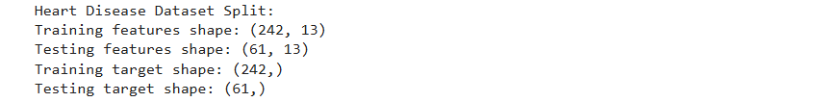

scaler_heart = StandardScaler()
X_train_scaled_heart = scaler_heart.fit_transform(X_train_heart)
X_test_scaled_heart = scaler_heart.transform(X_test_heart)

print("Features scaled for Heart Disease dataset.")
print("First 5 rows of scaled training data:")
display(pd.DataFrame(X_train_scaled_heart, columns=X_heart.columns).head())
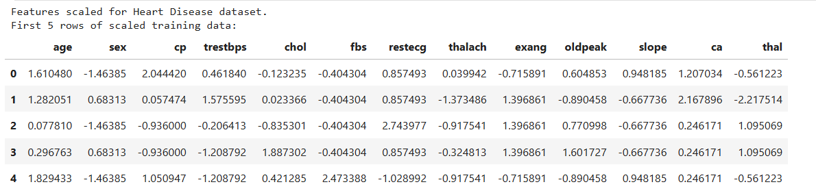
accuracy_scores_heart = []
k_values = range(1, 40)
for i in k_values:
knn = KNeighborsClassifier(n_neighbors=i)
knn.fit(X_train_scaled_heart, y_train_heart)
y_pred_heart_k = knn.predict(X_test_scaled_heart)
accuracy_scores_heart.append(accuracy_score(y_test_heart, y_pred_heart_k))
plt.figure(figsize=(10, 6))
plt.plot(k_values, accuracy_scores_heart, color='blue', linestyle='dashed', marker='o',
markerfacecolor='red', markersize=10)
plt.title('Accuracy vs. K Value for Heart Disease')
plt.xlabel('K Value')
plt.ylabel('Accuracy Score')
plt.xticks(np.arange(1, 40, 2))
plt.grid(True)
plt.show()
optimal_k_heart = k_values[np.argmax(accuracy_scores_heart)]
max_accuracy_heart = np.max(accuracy_scores_heart)
print(f"Optimal K value for Heart Disease: {optimal_k_heart}")
print(f"Maximum Accuracy for Heart Disease at optimal K: {max_accuracy_heart:.4f}")
k_heart = optimal_k_heart
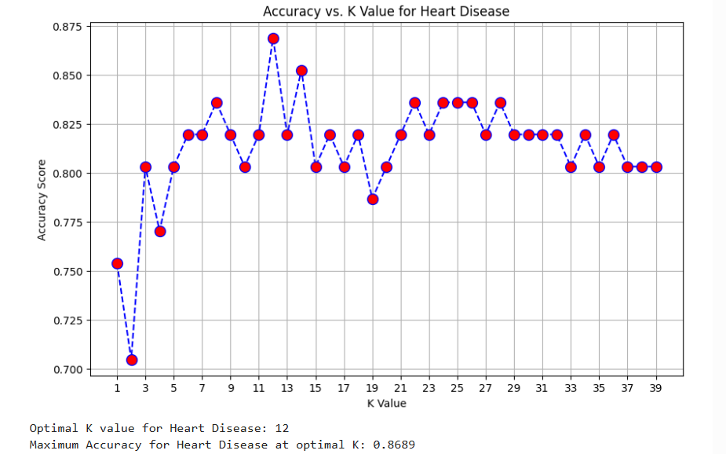
knn_heart = KNeighborsClassifier(n_neighbors=k_heart)

knn_heart.fit(X_train_scaled_heart, y_train_heart)

y_pred_heart = knn_heart.predict(X_test_scaled_heart)

accuracy_heart = accuracy_score(y_test_heart, y_pred_heart)
print(f"Accuracy Score for Heart Disease KNN: {accuracy_heart:.4f}")

conf_matrix_heart = confusion_matrix(y_test_heart, y_pred_heart)
print("\nConfusion Matrix for Heart Disease:\n")
display(conf_matrix_heart)

class_report_heart = classification_report(y_test_heart, y_pred_heart)
print("\nClassification Report for Heart Disease:\n")
print(class_report_heart)

